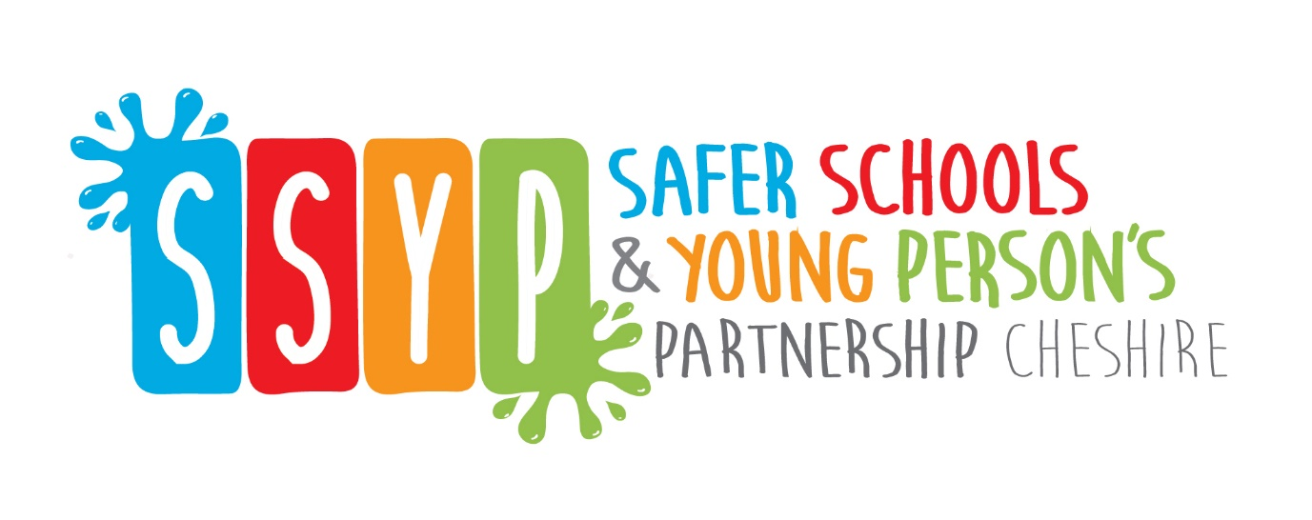
SSYP Newsletter – Edition 3
Welcome All,
In the third addition of our newsletter we are focusing on Exercise and Wellbeing.
Exercise and physical activity are great ways to feel better, improve your health and make you feel better about yourself. Experts say engaging in regular activity throughout the week is a great way to boost your own morale and will therefore assist you focusing on your school work, which we know, many of you are doing from home.
Below we will outline and signpost you to some websites we have enjoyed and think you will too.
The current NHS Guidelines recommend teenagers exercise for 1 hour a day. Whilst we don’t expect our teenager to be hopping, skipping, jumping and doing bear crawls in the living room we do advise that they make every effort to use their hour in the fresh air. It is well documented that teenagers with use more energy and be active outdoors. So maybe give them a shopping list, an item to post, or something to collect so they have a reason to break free from their studies at home.
The Body Coach
Click on this link to access his YouTube channel - https://youtu.be/66EyFKtb7Fw
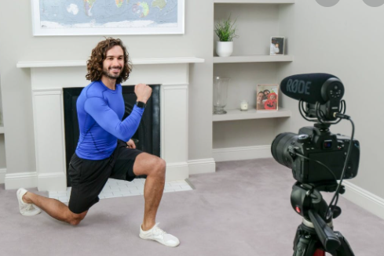
We have all heard of Joe Wicks, also known as the body coach. He is a TV presenter and author and arguably the most well-known British Fitness Coach.
His method uses HIIT workouts, these are short intense High Intensity Interval Training.
During the first lockdown his 9am family HIIT Sessions were a huge hit with the nation. You can still participate in these session at 9am on Monday, Wednesday and Friday.

As well as physical exercise, exercising the mind is also really important. It can assist with improved concentration, mental clarity, emotional intelligence and the ability to relate to others with kindness, compassion and acceptance.

If the Body Coach is not for you, here are two more YouTube Channels which feature a lot of physical exercise and workouts at home – directed specifically towards teens/young adults.
KlikKluK - YouTube
Kendrick Chavez - YouTube

Mindfulness
A new study suggests that mindfulness education (lessons on techniques to calm the mind and body) can reduce the negative effects of stress and increase students’ ability to stay engaged, helping them stay on track academically and avoid behaviour problems.
It can also help both teachers and students to reduce stress and anxiety, strengthen attention and focus, support social and emotional growth, and better resolve the inevitable conflicts that arise.
Not only can it relieve stress, but it can lower blood pressure, reduce pain, and help to improve sleep and mental health.
If you feel stressed, unhealthy and unhappy, you may be ready to introduce mindfulness and/or meditation into your life. It is proven that if you learn how to sit quietly with yourself and calm your brain, you will discover a whole new world of contentment and serenity. Your physical aches and pains will melt away as your body and mind learn the keys to true happiness.
Among its theorized benefits are self-control, objectivity, affect tolerance, enhanced flexibility, equanimity, improved concentration and mental clarity, emotional intelligence and the ability to relate to others and one’s self with kindness, acceptance and compassion.

Follow this link for 10 Mindfulness Activities for Teens

www.mentalup.co/blog/mindfulness-activities-for-teens

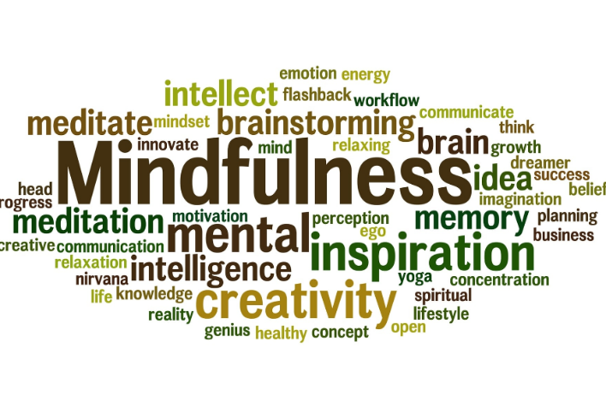

***Want to stay in touch please follow our Safer Schools and Young person Facebook and Twitter account ***

Follow @cheshirepolice on Twitter | Like Cheshire Police on Facebook Follow @CheshireSSYP on Twitter

Pc 5403 Suzi Williams
Youth Engagement Officer, Safer Schools Partnership
