Willow Class
Weekly Writing Tasks – 08/06/2020

Monday  08/06 | 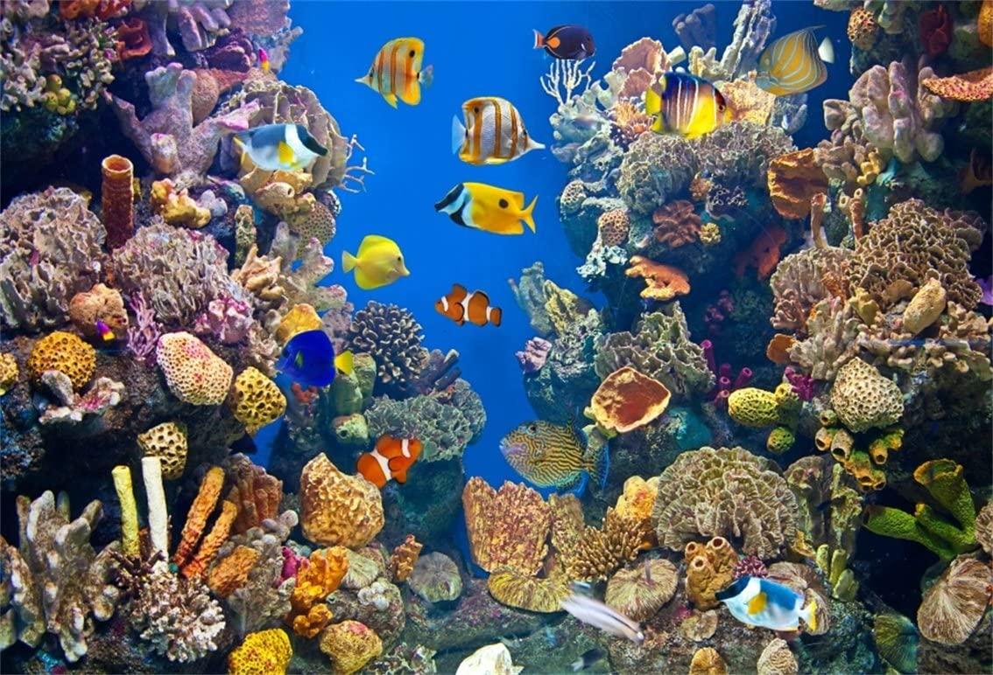  I can describe a setting  Write a description of this image. Think about what you can see, what the colours are, what the creatures and coral may feel like and the temperature of the water.  Year 1 - remember to use your capital letters and full stops.
Tuesday  09/06 | I can write a character description  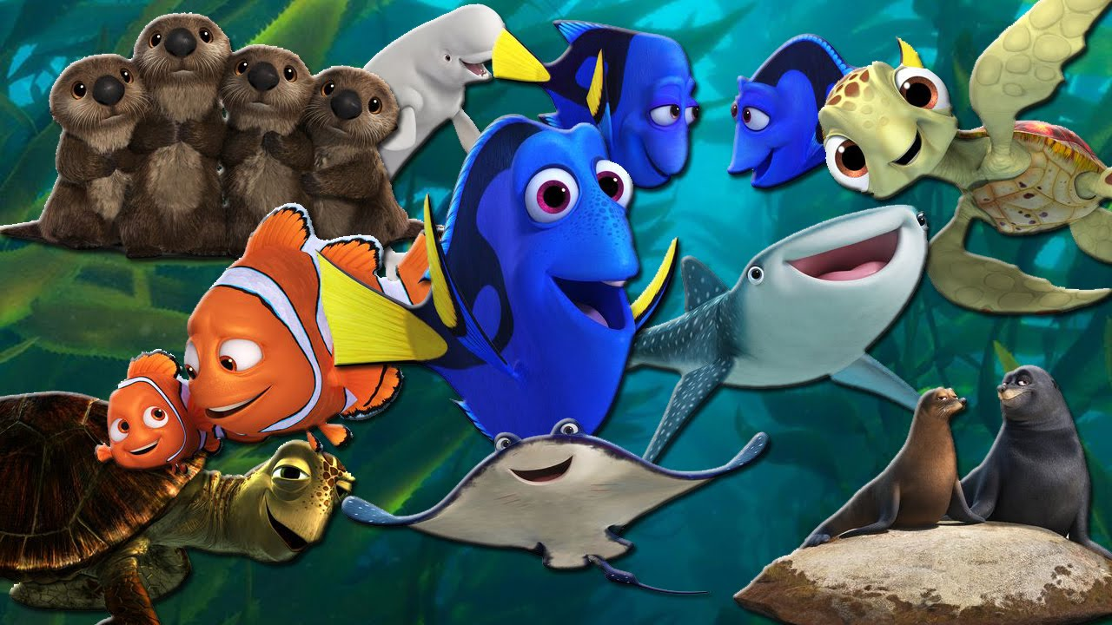  Use the image above and choose one of the characters. Think about including what they look like but also think about what they are doing. E.g. The beautiful clownfish with orange and white stripes swims carefully in the blue sea.  Year 1 – remember to use ‘and’ to join ideas together and use capital letters and full stops.
Wednesday  10/06 | I can write a fact file  I have attached a document with a fact file for you to complete about your chosen sea creature. Additionally, I have included a powerpoint with information about a variety of sea creatures that you can use, or you may also research using the internet or books.  Year 1 – write in sentences.
Thursday  11/06 | I can make comparisons  Use the comparison chart attached below, choose two sea creatures (from the powerpoint or choose your own) and complete the chart by describing both creatures. Think about what they both look like, what they eat and how they move in the water.  Year 1 – use sentences when comparing.
Friday  12/06 | I can write a diary entry  Imagine that you are going on a journey under the sea. https://www.youtube.com/watch?v=hXtrIy95V80  Think about how you will get into the water, what you will see when you are swimming under the water and how it makes you feel. Remember to include the date at the top of the page and start with Dear Diary.  Dear Diary, I jumped off the smooth rock and splashed into the water. I swam slowly in the sea and spotted so many colourful fish. The beautiful starfish and sea turtles were my favourite creatures to swim past. It felt colder and colder as I swan further down in the sea so I didn’t stay under the water for too long. I enjoyed my journey under the sea because it made me happy to see all of the fantastic creatures and pretty coral.  Year 1 – try and use ‘because’ in at least one sentence.

Thursday 11th June 2020

I can make comparisons

