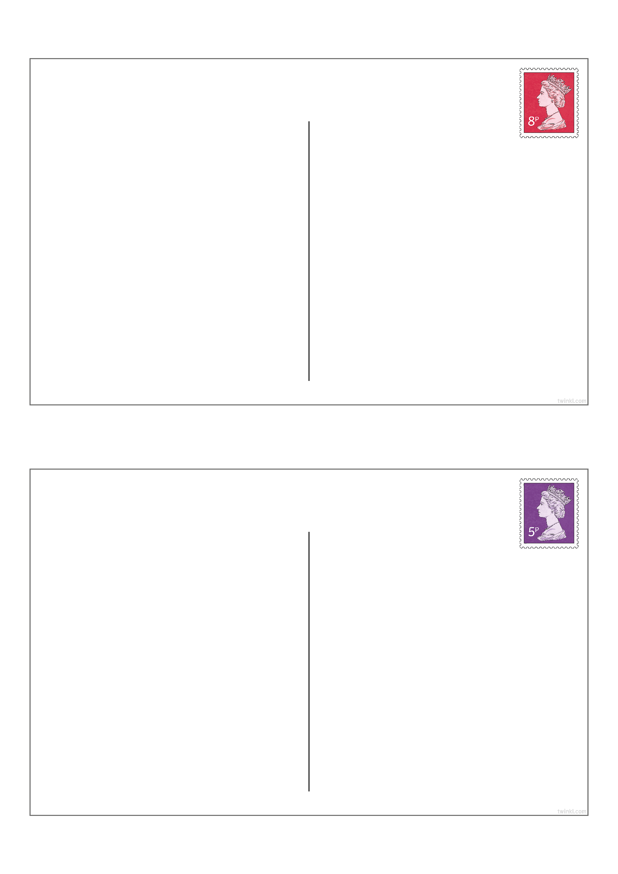
A Postcard to School
A Postcard to School
Enter Text Here
Enter Text Here

