Daily tasks
Reading  Read any books for pleasure, to yourself, to someone at home or they can read to you.  Your books and tasks are still available on Active Learn – Bug Club. Please email me if you need any new books.  For your English work, we will be looking at some non-fiction texts this week with a focus on information. | Phonics  Practise your phonics. Children have a booklet of phonics activities for the phase that they are working within (aim for one at least one page completed a day).  Continuing this week, the Department of Education, in partnership with the English Hub, have produced a series of daily Letters and Sounds videos to support the delivery of phonics lessons at home. You can subscribe and find out more information by following the link:  https://www.youtube.com/channel/UCP_FbjYUP_UtldV2K_-niWw |  | Maths  EYFS:  Practise writing numbers to 20. Order numbers to 20, not always starting from 0. Order lengths of objects (sticks are really good for this activity).  Year 1:  Practise number bonds to 10 and 20. Look at the length, weight and height of objects. Use objects like cubes or even pasta to measure items.  Free resources - daily lessons/activities for you to follow: https://whiterosemaths.com/homelearning - then click on EYFS or Year 1 – they follow on from our learning in school.  You can also log into Education City and practise your maths with games.
Tasks that I can select each day
We are all scientists!  For Science this week, Mrs Crook has uploaded a blog post with information about science activties that you can carry out. This week’s is all about foraging.  ‘The Great Science Share 2020’  https://www.westfieldprimaryschool.com/serve_file/581357 | Physical activity  Get your hearts racing by doing at least 10 minutes of exercise every day. Try ‘Cosmic Kids Yoga’ or here is something new to our grid from Cbeebies - https://www.bbc.co.uk/cbeebies/grownups/fun-exercises-to-do-at-home-with-kids | Geography  Create a map or picture of one or more of your daily walks. Label the physical features that you see: beach, cliff, coast, forest, hill, sea, river, soil, field, forest, season and weather and the human feature: city, town, village, factory, farm, house, office, port, shop. |  | DT/Art  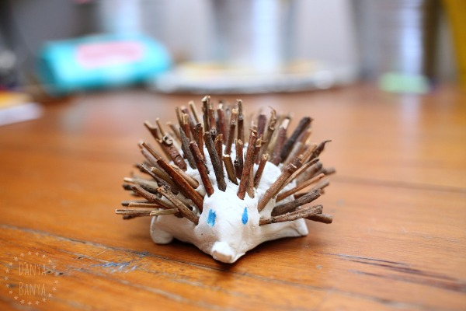  Can you make an animal out of playdough and natural resources like this hedgehog?
Family time  Take this opportunity to spend some quality time with your loved ones. Play games, read books together, watch a film, eat dinner together, make dens, put on some music and have a song and dance session! | Life Skills  This week, continue with your independence skills. Can you make your bed by yourself, brush your teeth, put your shoes on, wash your hair and get dressed by yourself at least twice a week? | Fun Activities  Some suggestions of optional activities:  - find a book in your house that is written by someone who has the same first letter as your first or second name,  - can you make a den somewhere in your house using blankets, pillows and cushions – maybe you could take your favourite book in there and send me a photo!
