Daily tasks
Reading  Read any books for pleasure, to yourself, to someone at home or they can read to you.  Your books and tasks are still available on Active Learn – Bug Club. Please email me if you need any new books.  For your English work, Julia Donaldson has made her stories available to watch for free on BBC iplayer, feel free to also read the book at home if you have it. I will then link the daily writing task to this story/book – this week, we will focus on ‘The Highway Rat’. | Phonics  Practise your phonics. Children have a booklet of phonics activities for the phase that they are working within (aim for one at least one page completed a day).  Continuing this week, the Department of Education, in partnership with the English Hub, have produced a series of daily Letters and Sounds videos to support the delivery of phonics lessons at home. You can subscribe and find out more information by following the link:  https://www.youtube.com/channel/UCP_FbjYUP_UtldV2K_-niWw |  | Maths  EYFS:  Practise matching numbers and amounts of objects with numbers to 20 and finding one more and one less of numbers to 10.  Year 1:  Practise number bonds to 10 and 20 and adding/subtracting numbers with two and one digits (27 + 8 = ?) (23 – 5 =).  You can also log into Education City and practise your maths with games.  Free resources - this website has planning that follows on from our learning in class. There is content for each week, with daily lessons/activities for you to follow:https://whiterosemaths.com/homelearning - then click on EYFS or Year 1
Tasks that I can select each day
We are all scientists!  For Science this week, Mrs Crook has uploaded a blog post with information about science activties that you can carry out. This week’s follows on from our work on Space from last week.  ‘The Great Science Share 2020’  https://www.westfieldprimaryschool.com/serve_file/559868 | Physical activity  Get your hearts racing by doing at least 10 minutes of exercise every day. Try ‘Cosmic Kids Yoga’ or here is something new to our grid from Cbeebies - https://www.bbc.co.uk/cbeebies/grownups/fun-exercises-to-do-at-home-with-kids | DT/Music  Look around your house at any recycling or parts/building materials that you can make a musical instrument out of. Play along to your favourite song or create your own tune. |  | Art  Can you make a piece of art work out of natural materials from the garden or found on your walk? My children collected leaves, twigs and fallen petals to create a love heart – see the photograph below.
Family time  Take this opportunity to spend some quality time with your loved ones. Play games, read books together, watch a film, eat dinner together, make dens, put on some music and have a song and dance session! | Life Skills  This week, I would like for you to practise some independence skills. Can you make your bed by yourself, brush your teeth, wash your hair and get dressed by yourself at least twice a week? | Fun Activities  Some suggestions of optional activities:  - can you create a tea party or picnic with your teddies/toys. Think about what they might need.  - can you collect items from your house or outside and put them into piles of the same colour?  - can you make shapes, number or letters out of sticks?
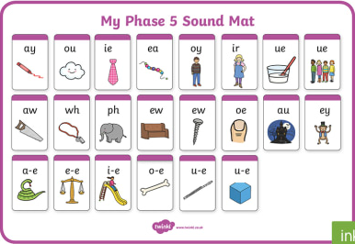
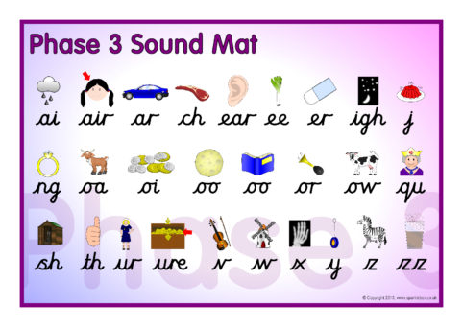

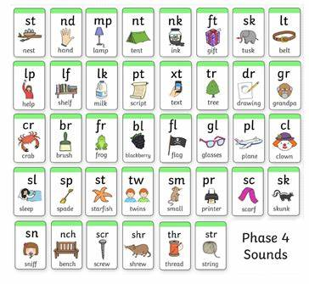

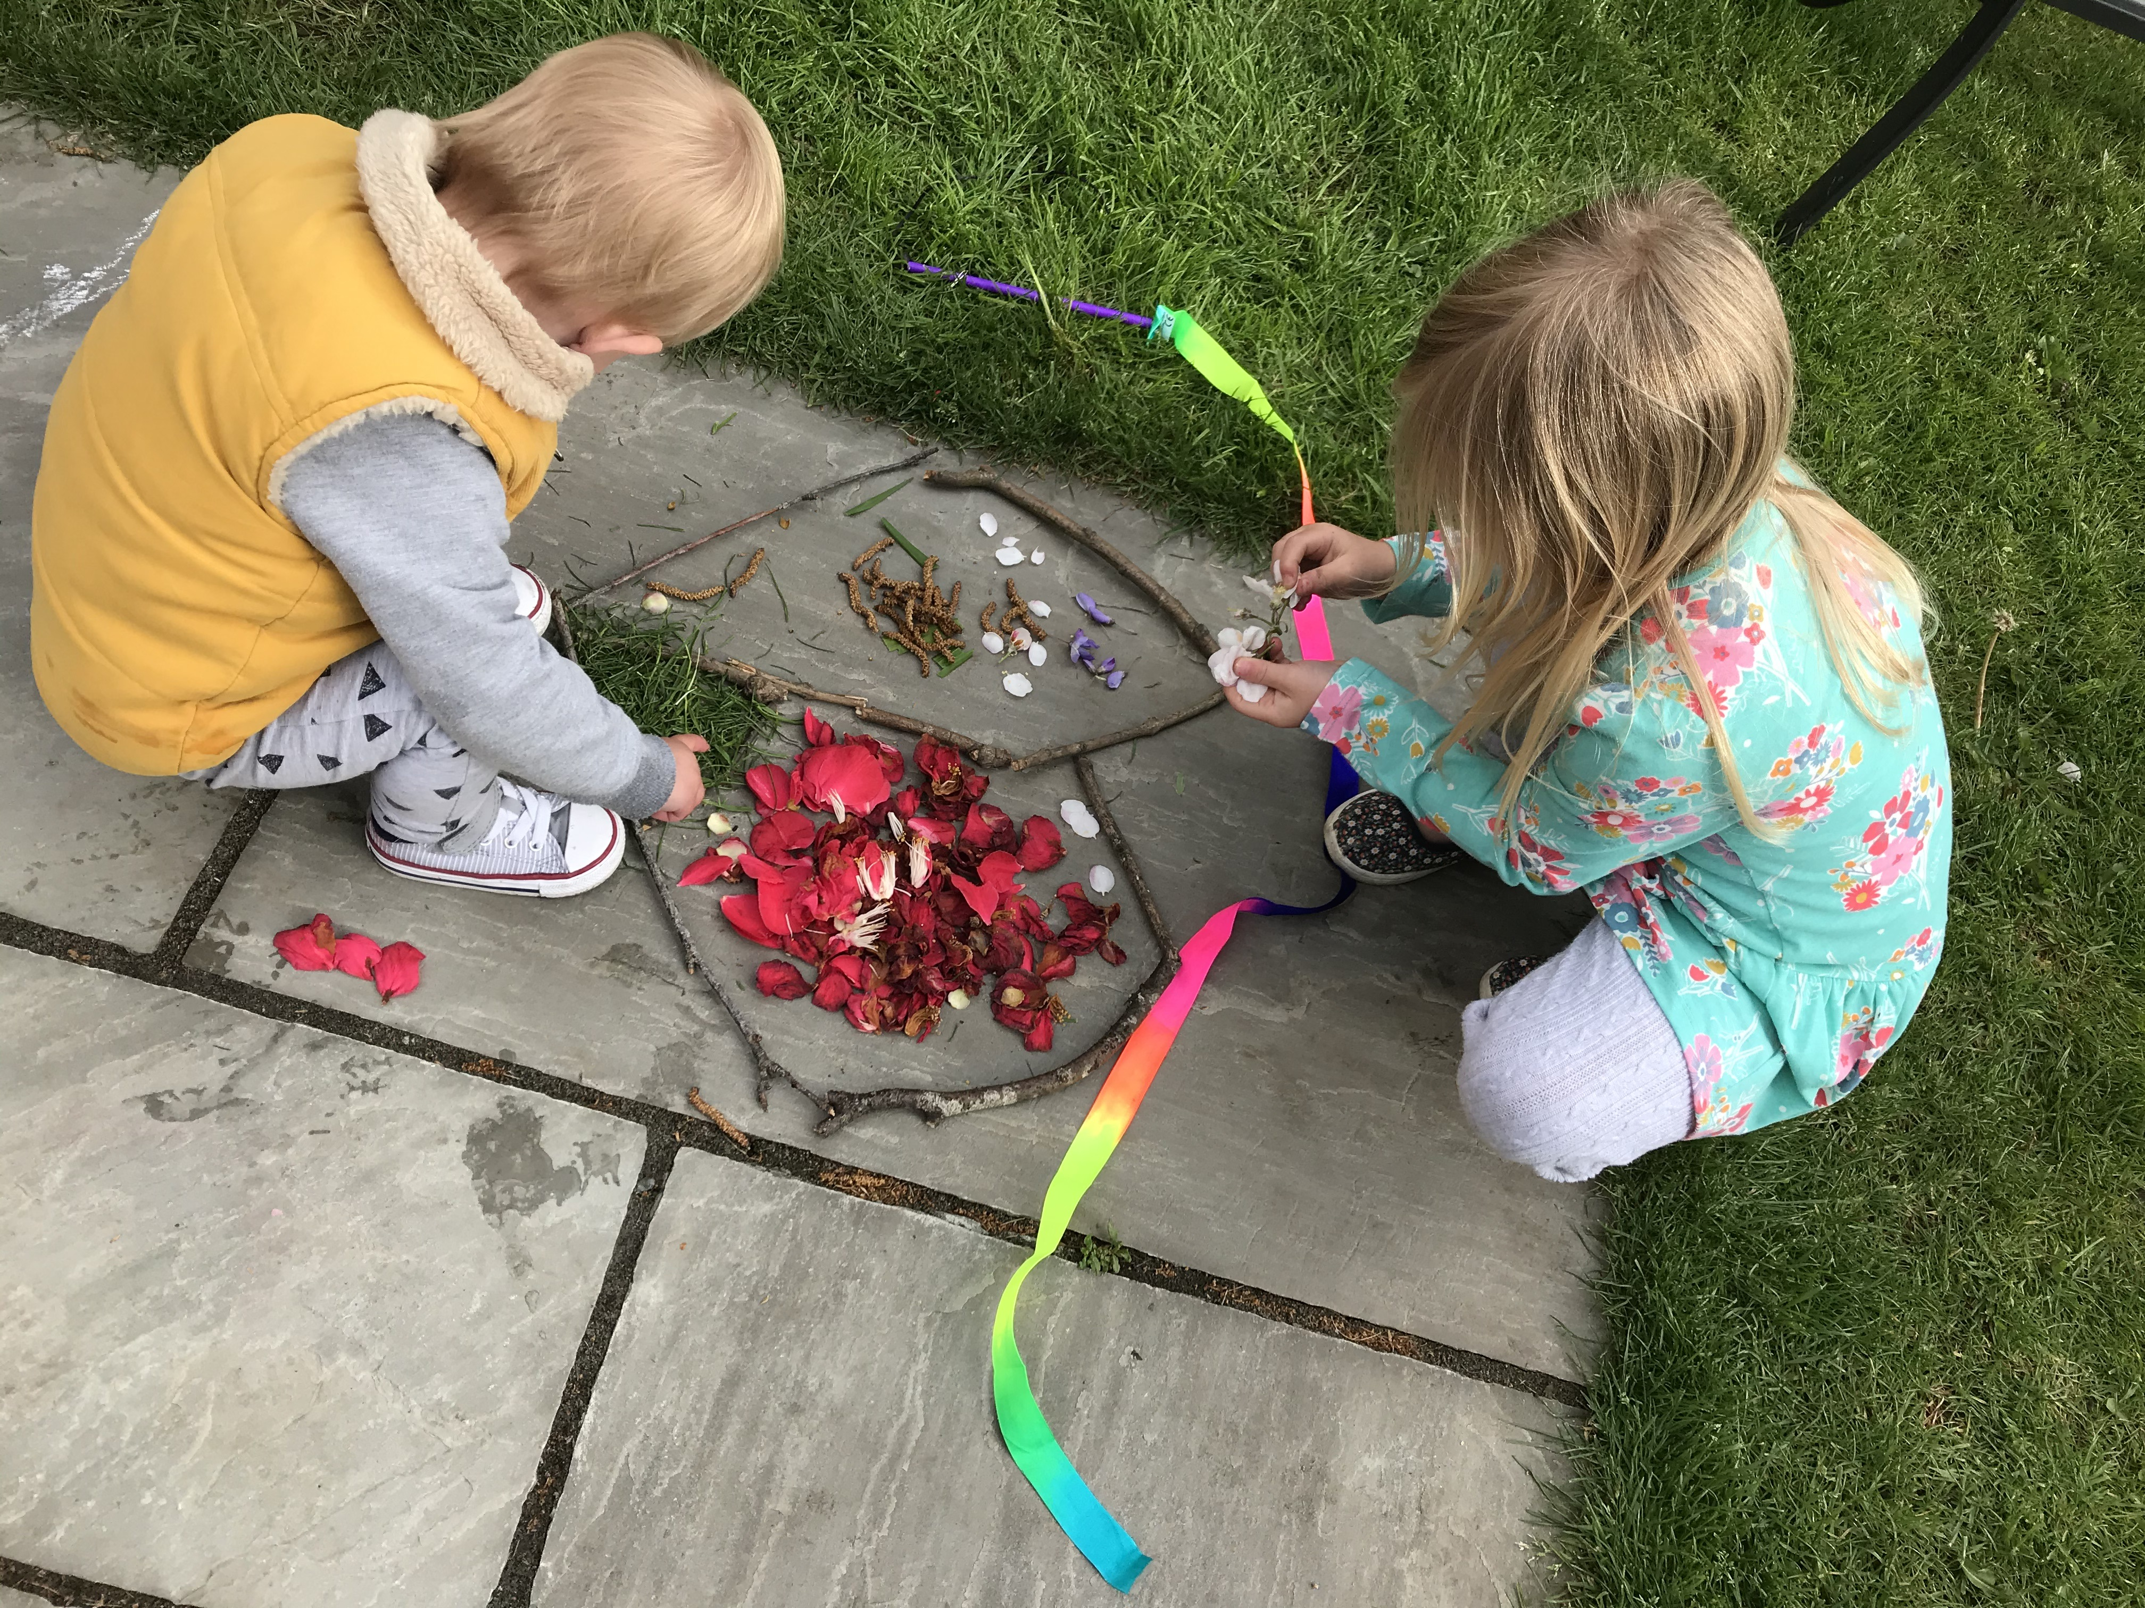
Harry and Amelia

