Daily tasks
Reading  Read any books for pleasure, to yourself, to someone at home or they can read to you.  Your books and tasks are still available on Active Learn – Bug Club. Please email me if you need any new books.  For your English work, Julia Donaldson has made her stories available to watch for free on BBC iplayer, feel free to also read the book at home if you have it. I will then link the daily writing task to this story/book – this week, we will focus on ‘Room on the Broom’. | Phonics  Practise your phonics. Children have a booklet of phonics activities for the phase that they are working within (aim for one at least one page completed a day).  Continuing this week, the Department of Education, in partnership with the English Hub, have produced a series of daily Letters and Sounds videos to support the delivery of phonics lessons at home. You can subscribe and find out more information by following the link:  https://www.youtube.com/channel/UCP_FbjYUP_UtldV2K_-niWw |  | Maths  EYFS:  Practise counting numbers to 20 and finding one more and one less of numbers to 10.  Year 1:  Practise number bonds to 10 and 20.  You can also log into Education City and practise your maths with games.  Free resources - this website has planning that follows on from our learning in class. There is content for each week, with daily lessons/activities for you to follow:https://whiterosemaths.com/homelearning - then click on EYFS or Year 1
Tasks that I can select each day
We are all scientists!  Following on from our learning in school about plants, try and collect different types of leaves from your garden or when on your daily walk. Stick the leaves into your book and describe their features (spiky, small, smooth, green, points go in and out). Can you also identify which tree the leaf is from?  Use the activities on Education City to help. | Physical activity  Get your hearts racing by doing at least 10 minutes of exercise every day. Try ‘Cosmic Kids Yoga ‘or ‘5 Minute Moves’ by ‘The Body Coach’ on YouTube. You could combine physical activity and learning by accessing Supermovers  https://www.bbc.co.uk/teach/supermovers | DT  Look around your house at any recycling or parts/building materials that you can make a rocket out of. Test your rocket to see how far it can travel.  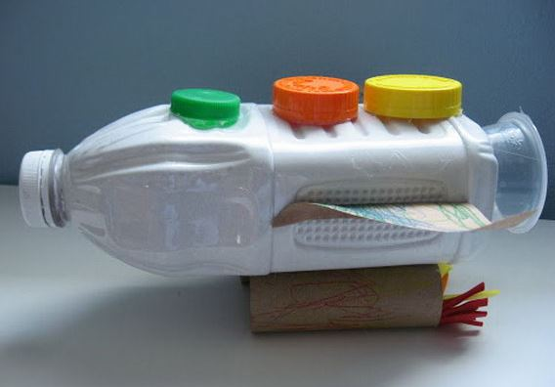 |  | History  Neil Armstrong  Research into who Neil Armstrong is and why he is famous, where did he go?  
Family time  Take this opportunity to spend some quality time with your loved ones. Play games, read books together, watch a film, eat dinner together, make dens, put on some music and have a song and dance session! | Life Skills  Tidying – this week, help with tidying up in your house. Could you help out by tidying your room or asking to help your parents tidy the kitchen or another room? | Fun Activities  Some suggestions of optional activities:  - write a letter to a friend or family member that you haven’t seen for a while – you could post it to them or send it over an email or message. If you choose a class friend, I can email it to them for you.  - make a potion using water/coloured water/mud/soap/flowers – think about what would happen if someone drank your potion!
