Daily tasks
Reading  Read any books for pleasure, to yourself, to someone at home or they can read to you.  Your books and tasks are still available on Active Learn – Bug Club. Please email me if you need any new books.  For your English work, Julia Donaldson has made her stories available to watch for free on BBC iplayer, feel free to also read the book at home if you have it. I will then link the daily writing task to this story/book – this week, we will focus on ‘Zog’. | Phonics  Practise your phonics. Children have a booklet of phonics activities for the phase that they are working within (aim for one at least one page completed a day).  Starting this week, the Department of Education, in partnership with the English Hub, have produced a series of daily Letters and Sounds videos to support the delivery of phonics lessons at home. You can subscribe and find out more information by following the link:  https://www.youtube.com/channel/UCP_FbjYUP_UtldV2K_-niWw |  | Maths  EYFS:  Practise counting and writing numbers from 0 to 20.  Year 1:  Practise counting in multiples of 2s, 5s and 10s – forwards and backwards.  You can also log into Education City and practise your maths with games.  Free resources - this website has planning that follows on from our learning in class. There is content for each week, with daily lessons/activities for you to follow:https://whiterosemaths.com/homelearning - then click on EYFS or Year 1
Tasks that I can select each day
We are all scientists!  Following on from our learning in school about plants, think about taking a pencil and paper or a camera on your walks this week. Take pictures or draw at least two different plants/trees/flowers and label or write about what is different.  Use the activities on Education City to help. | Physical activity  Get your hearts racing by doing at least 10 minutes of exercise every day. Try ‘Cosmic Kids Yoga ‘or ‘5 Minute Moves’ by ‘The Body Coach’ on YouTube. You could combine physical activity and learning by accessing Supermovers  https://www.bbc.co.uk/teach/supermovers | Art  Continue - look at the painting by Van Gogh – A Starry Night. Can you create your own version of this painting? You can use any materials that you like.  Create your own landscape picture, either of the view outside of a window or on your daily walk. |  | History  Talk to your parents or grandparents (if you live with them or on video chat) about the toys and games that they used to play when they were children. Are they similar or different to your toys and games? I have found my old Polly Pockets that are a lot bigger than they are now!
Family time  Take this opportunity to spend some quality time with your loved ones. Play games, read books together, watch a film, eat dinner together, make dens, put on some music and have a song and dance session! | Life Skills  Cooking – this week, try and either help with cooking part or all of a meal, baking or food preparation. You could help to cut fruit or vegetables, make a sandwich, pour drinks for your family or take the plates out ready for meal time. | Fun Activities  Some suggestions of optional activities:  - write a letter to a friend or family member that you haven’t seen for a while – you could post it to them or send it over an email or message. If you choose a class friend, I can email it to them for you.  - build a fort/den out of cushions, pillows, blankets and play castles, have a picnic lunch in it or read books.
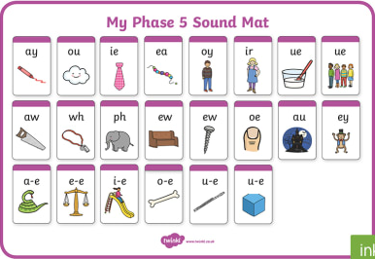
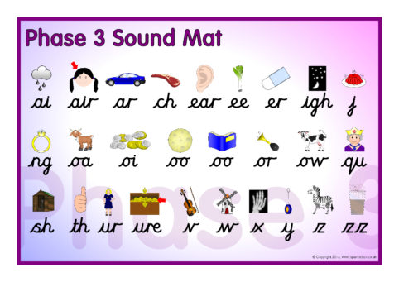

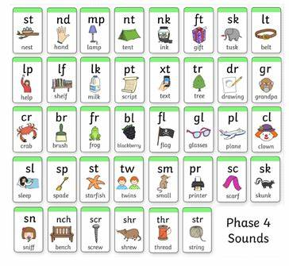

Van Gogh – A Starry Night
