Daily tasks
Reading  Read any books for pleasure, to yourself, to someone at home or they can read to you.  Your books and tasks are still available on Active Learn – Bug Club. Please email me if you need any new books.  For your English work, Julia Donaldson has made her stories available to watch for free on BBC iplayer, feel free to also read the book at home if you have it. I will then link the daily writing task to this story/book – this week, we will focus on ‘The Gruffalo’. |  | Phonics  Practise your phonics. Children have a booklet of phonics activities for the phase that they are working within (aim for one at least one page completed a day). Also, here are some free interactive websites that might help:  https://www.phonicsplay.co.uk/freeIndex.htm  https://www.education.com/games/phonological-awareness/  https://monsterphonics.com/games/ |  | Maths  EYFS:  Practise counting numbers from 0 to 20.  Year 1:  Practise counting in multiples of 2s, 5s and 10s – forwards and backwards.  You can also log into Education City and practise your maths with games.  This website has planning that follows on from our learning in class. There is content for each week, with daily lessons/activities for you to follow:https://whiterosemaths.com/homelearning - then click on EYFS or Year 1
Tasks that I can select each day
We are all scientists!  Following on from our learning in school about plants and common animals, think about taking a pencil and paper or a camera on your walks this week. Take pictures or draw and write about any common animals that you see. Can you observe a plant closely and label the parts?  Use the activities on Education City to help. | Physical activity  Get your hearts racing by doing at least 10 minutes of exercise every day. Try ‘Cosmic Kids Yoga ‘or ‘5 Minute Moves’ by ‘The Body Coach’ on YouTube. You could combine physical activity and learning by accessing Supermovers  https://www.bbc.co.uk/teach/supermovers |  | Art  Look at the painting by Van Gogh – A Starry Night. Can you create your own version of this painting? You can use any materials that you like, it does not have to be in paint. |  | Design and Technology  Can you design a boat that will be able to float on water? Find objects in your home that can fit into your boat.
 |  |  |  |  | Feel free to email any pictures to me also – mrsmcilroy@westfieldprimaryschool.com
Family time  Take this opportunity to spend some quality time with your loved ones. Play games, read books together, watch a film, eat dinner together, make dens, put on some music and have a song and dance session! | Life Skills  Kindness – think of an act of kindness that you can do for someone in your house or for your neighbours. You could draw a picture, write a card, give someone in your house a compliment, offer help to make dinner or tidy up. |  | Fun Activities  Some suggestions of optional activities:  - look around your home. How many items can you find that are these 3-D shapes – cube, cuboid, cylinder, cone, pyramid, sphere  - hide an item around your house and give a family member positional directions to find the item – left, right, forwards, backwards, half turn, quarter turn.
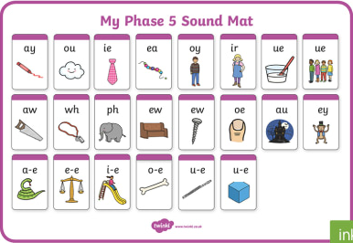
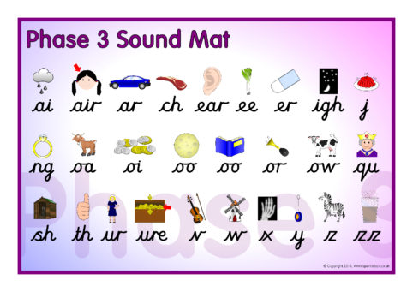

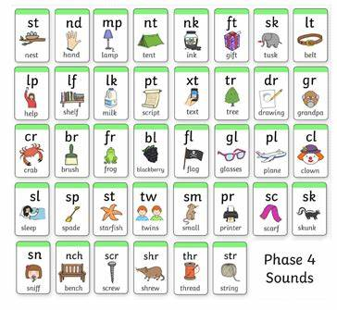

Van Gogh – A Starry Night
