Wellbeing Workshop – Year 1&2 Children and Parents

Would you like to have the opportunity to work with your child in school?

Dear Parent/Guardian/Grandparent
School has booked the Family Learning tutors from Halton Borough Council to run a ‘Wellbeing Workshop’ for families in Year 1 & 2 at school on Thursday 6th February 2020 from 9.00 – 10.30 am. During this time you are invited to join your child in school for a variety of fun and hands on activities that focus on, and create discussion around, how we can ensure we have a healthy lifestyle and good mental wellbeing.
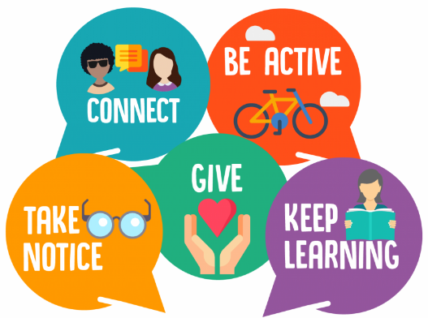

Activities will focus on the 5 Ways to Wellbeing
- Yoga
- Keep fit exercises
- Positive thinking
- Mindfulness meditation
- Considering others

---------------------------------------------------------------------------------------
Please complete the slip below and return it to school to book your place.

I would like to attend the ‘Wellbeing Workshop’ for Year 1&2 children.

Parent’s Name:_________________________________________________________

Child’s/Children’s name(s):______________________________________________

Child’s/Children’s Year Group(s):_________________________________________

