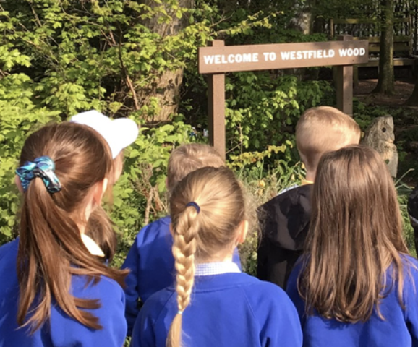

REMINDER

**All pupils need to bring water bottles and sun hats with them to school, and have sun cream applied before coming into school each day**

**Dates for your Diary**

**Tuesday, 13th June**

Cherry Class go to the Fire Station Community Garden

**Wednesday, 14th June**

Gifted & Talented at the Heath School

**Friday, 16th June**

Year 6 – First Aid

**Other Awards**

Tidiest Classroom – Oak Class

Ms Powell – Lexi, Larch Class

Headteacher Award – Annie, Willow Class

h

**Star of the Week**

Willow – George

Cherry – Freddie

Larch – Daisy

Oak – Lillie

**Attendance**

Willow – 88.1%

Cherry – 93.4%

**Larch – 93.9%**

**Oak – 93.9%**

Whole school – 92.8%

**PuntualityAward**

Willow Class

**Any questions or comments? Please send us an email.**

**School:** **sec.westfield@haltonlearning.net**

**Headteacher – Miss S. Pope:** [**head.westfield@haltonlearningnet**](mailto:head.westfield@haltonlearningnet)

Promoting independence, individuality and an inquisitive mind.

**Westfield Primary School**

**9th June 2023**